 | 
AIM Enhancements – Phase I
Business Specifications Document


AIM for Complex Orders

Final Version
Date: 25th February 2008

Table of Contents
1 AIM AON Auction Specifications for Complex Orders 3
1.1 General Business Rules 3
1.2 Receiving a Complex Order for AIM from CMi or FIX 3
1.3 AIM Mechanism for Complex Orders 3
1.3.1 AIM Auction Eligibility 3
1.3.2 Auction Starting Price 6
1.3.3 Pre-Auction Cleanup 6
1.3.4 Start of Auction 6
1.3.5 Joining an on-going Auction 7
1.3.6 During Auction 7
1.3.7 End of Auction Allocation / Trading 8
1.4 AIM Order Cancellation 9
1.5 Clearing Consideration 9
1.6 AIM Auction Configuration 9
1.7 Trader GUI related changes 10
1.8 Acronyms and Definitions 12

AIM AON Auction Specifications for Complex Orders

General Business Rules
- Auto-match is allowed and the MO must match Auction Responses, Quotes, and I-Orders only.
- Assumed that DSM is based of BBO and not NBBO.
- Option Leg books must be monitored during the AIM auction.
- BOB classes are also eligible for AIM auction.
- After the AIM auction starts, for any known reason the AIM order must not be CANCELLED without getting allocated.
- Requirements for AON Solicitation Mechanism for Complex Orders are not detailed in this document for now.
- Requirements for AIM for Cross Product Spreads are not detailed in this document for now.

Receiving a Complex Order for AIM from CMi or FIX
- The sources for the Complex Orders for AIM auction could only be from either CMi or FIX.
- The ‘Optional Data’ field must have either A:AIM or A:AIR
- The AIM order can be submitted either as a TIED/PAIRED order or as two separate orders.
- The Order Handling Instruction Type must be 'A' (i.e. Auction).

AIM Mechanism for Complex Orders

AIM Auction Eligibility
To be eligible to start the AIM auction, the PO can be either a Market Order or a Limit Order whose price must be as either one of the following:

- Irrespective of whether PO is a Customer or Non-Customer Order, if PO price is inside the DSM and if there is a Customer Order TSB then PO price must be at least one tick BETTER than that resting CO
e.g. DSM is 1.00 – 1.40
- TSB is 1.05 on Same As Defined side with a CO
- PO price must be GREATER than 1.05 (i.e. 1.06 or better within the market up to 1.39)

- If PO is a Customer Order and if PO price is inside the DSM and if there is a Non-Customer Order TSB then PO price must be at least EQUAL to or BETTER than that resting Non-Customer Order
e.g. DSM is 1.00 – 1.40
- TSB is 1.05 on Same As Defined side with a Non- Customer Order
- PO price must be at least EQUAL to or GREATER than 1.05 (i.e. 1.05 or better within the market up to 1.39)

- If PO is a Non-Customer Order and PO price is inside the DSM and if there is a Non-Customer Order TSB then PO price must be at least one tick BETTER than that resting Non-Customer Order
e.g. DSM is 1.00 – 1.40
- TSB is 1.05 on Same As Defined side with a Non-Customer Order
- PO price must be GREATER than 1.05 (i.e. 1.06 or better within the market up to 1.39)

- Irrespective of whether PO is a Customer or Non-Customer Order, if PO price is inside the DSM and if there is no TSB then PO price must be at least one tick BETTER than the SAME side DSM
e.g. DSM is 1.00 – 1.40
- No TSB
- PO price must be GREATER than 1.00 (i.e. 1.01 or better within the market up to 1.39)

(Note: The system must check the PO price and the MO price to validate if the Primary order is to be AIM auctioned or to trade with the Matched order or CANCEL both orders. In order to avoid the impact of changing markets, the above check has to be performed in CBOEdirect in spite of the TSB verification already done by TPF.)

The following are some of the scenarios where AIM auction either must be started or must not be started based on defined criteria:
- If the PO price is WORSE than the current BSM then AIM auction must not be started and then CANCEL both sides of the AIM order.
e.g. DSM is 1.00 – 1.40
- If PO price is less than 1.00 (i.e. 0.99 or so) then the AIM Order must be CANCELLED

- If the MO price is AT the OPPOSITE side DSM then AIM auction must not be started and then CANCEL both sides of the AIM order.
e.g. DSM is 1.00 – 1.40
- If PO price is less than 1.00 (i.e. 0.99 or so) then the AIM Order must be CANCELLED

- If Auction Starting Price is outside the current BSM, then the AIM auction must not be started and then CANCEL both sides of the AIM order.
e.g. DSM is 1.00 – 1.40
- If PO price is 1.40 and MO is greater than 1.40 (i.e. 1.50 or so) then the AIM Order must be CANCELLED

- If PO price is MKT or is a marketable order and if MO price is at opposite side DSM then the AIM auction must not be started and then CANCEL both sides of the AIM order.

- If PO price is MKT and if MO price is also MKT then AIM auction must START with the Auction Starting Price as one TICK better than OPPOSITE side DSM and then trade as per End of Auction Allocation specifications

- If the MO price locks or inverts the market then the system must do as follows.
  - If the MO price is EQUAL to or BETTER than the best customer book on the SAME side of the PO, and
    - If PO is Customer or Non-Customer Order and price equal to TSB then the AIM auction must not be started and then CANCEL both sides of the AIM order
e.g. DSM is 1.00 – 1.40
- TSB is 1.05 on Same As Defined side with a Customer Order
- Consider PO price is 1.05 or 1.06 and if MO price is 1.05 or 1.04 or 1.03 or so
- If PO price is 1.05 and irrespective of it being a Customer or Non-Customer Order and irrespective of the MO price then both PO and MO are CANCELLED
- If PO price is 1.06 and irrespective of it being a Customer or Non-Customer Order and irrespective of the MO price the ASP must be 1.06 and MO + Auction Responses have to trade finally at 1.06

  - If the MO price is EQUAL to or BETTER than the best non-customer book on the SAME side of the PO, and
    - If PO is a Customer Order then AIM auction must be started and PO must trade with the MO at the best non-customer price.
e.g. DSM is 1.00 – 1.40
- TSB is 1.05 on Same As Defined side with a Non-Customer Order
- Consider PO is 1.05 or 1.06 and if MO is 1.05 or 1.04 or 1.03 or so
- If PO price is 1.05 and is a Customer Order then irrespective of the MO price the ASP must be 1.05 and MO + Auction Responses have to trade finally at 1.05
- If PO price is 1.06 and is a Customer Order then irrespective of the MO price the ASP must be 1.05 and MO + Auction Responses have to trade finally at 1.05

    - If PO is a Non-Customer Order and price equal to TSB then the AIM auction must not be started and then CANCEL both sides of the AIM order
e.g. DSM is 1.00 – 1.40
- TSB is 1.05 on Same As Defined side with a Non-Customer Order
- Consider PO price is 1.05 or 1.06 and if MO price is 1.05 or 1.04 or 1.03 or so
- If PO price is 1.05 and is a Non-Customer Order and irrespective of the MO price then both PO and MO are CANCELLED
- If PO price is 1.06 and is a Non-Customer Order then irrespective of the MO price the ASP must be 1.06 and MO + Auction Responses have to trade finally at 1.06

  - If the MO price is EQUAL to or BETTER than the DSM on the SAME side of the PO (i.e. no TSB), and
    - If PO is a Customer or Non-Customer Order and price equal to SAME side DSM then the AIM auction must not be started and then CANCEL both sides of the AIM order
e.g. DSM is 1.00 – 1.40
- No TSB
- Consider PO price is 1.00 and if MO price is 1.00 or 0.90 or so
- If PO price is 1.00 then irrespective of the MO price then both PO and MO are CANCELLED
- If PO price is 1.01 and is a Customer or Non-Customer Order then irrespective of the MO price the ASP must be 1.01 and MO + Auction Responses have to trade finally at 1.01

- If there is no DSM available, as the spread product will not be OPEN, then the AIM auction must not be started and the system must CANCEL both sides of the AIM order.

Auction Starting Price
The system must always take the MO Price as the Auction Starting Price and must be inside the market except for the following cases.
- If there is a Customer TSB on the SAME side of the PO and irrespective of PO being a Customer or Non-Customer Order if MO price CROSSES or EQUALS that SAME side TSB then ASP must be one AUCTION TICK BETTER than the Customer TSB price.
- If there is a Non-Customer TSB on the SAME side of the PO and if PO is a Customer Order and MO price CROSSES or EQUALS that SAME side TSB then ASP must be the TSB price.
- If there is a Non-Customer TSB on the SAME side of the PO and if PO is a Non-Customer Order and MO price CROSSES or EQUALS that SAME side TSB then ASP must be one AUCTION TICK BETTER than the Non-Customer TSB price.
- If there is no TSB then irrespective of whether PO is a Customer or Non-Customer Order if the PO price is at least one tick BETTER than the SAME side DSM and MO price CROSSES or EQUALS the DSM on the SAME side of the PO then ASP is one AUCTION TICK BETTER than that SAME side DSM

(Note:
- If leg markets have zero bid prices and the resulting BSM is a zero on the SAME side then the Auction Starting Price is at number of ticks equal to TOTAL OF THE RATIO of same side legs worse than zero
Example:
Consider a strategy product defined as Buy-Buy
Leg1: 0 – 0.2 0x100
Leg2: 0 – 0.2 0x100

DSM is 0 – 0.4
For an incoming opposite side order, opposite leg market is zero. So the auction must start at 0.02 because of 2 same side legs.)

Pre-Auction Cleanup
Before actually starting the AIM auction, the system must do the following cleanup activities.
- Check all legs to see if there is any Quote Lock or Quote Trigger or an on-going auction on any leg and force to end all of them if there are any.
- Check if there is any Quote Lock or Quote Trigger or an on-going auction on the strategy product and force to end all of them if there are any.

Start of Auction
The system must start the auction; send out an RFP, and remember the DSM and monitor the legs from the time when the auction is started.

Joining an on-going Auction
AIM auction does not allow joining of orders during auction on the side of the Primary Order. Hence there are no cases for new orders to join an on-going auction.

During Auction
The system must do the following:
- Collect all RFP responses.
- Monitor the following on the legs and the strategy product to check for premature auction ending conditions.
  - Quote Lock
  - Quote Trigger
  - New auction
  - Incoming Orders
- Monitor the following conditions:
  - An incoming order on the SAME side or the OPPOSITE side of the auction with a worse price than the Auction Starting Price must be
    - Booked, if the instruction is BOOK or AUCTION + BOOK. Auction is not impacted.
    - Returned with TSB if the instruction is AUTO-EX. Auction is not impacted.
- Monitor if the market moves in such a way that the auctioned AIM order is outside of the DSM range and then must prematurely end the auction and trade as per End of Auction specifications.

Premature Ending w.r.t. legs
The auction must end prematurely if any one of the following conditions on legs is met.
- An incoming Quote or Quote like order on any of the strategy's leg which would cause a Quote Lock or Quote Trigger must prematurely end the AIM auction and then traded as per End of Auction Allocation specifications.
- An incoming Non-Quote like order on any of the strategy's leg which would trade with the quotes must prematurely end the AIM auction and then traded as per End of Auction Allocation specifications.
- An incoming auction on any of the strategy's leg must prematurely end the AIM auction and then traded as per End of Auction Allocation specifications.

Premature Ending w.r.t. Strategy Product
The auction must end prematurely if any one of the following conditions on strategy product is met.

- An incoming Quote or Quote like order on the strategy leg which would result in a Quote Lock or Quote Trigger must prematurely end the AIM auction and then traded as per End of Auction Allocation specifications.
- ANY incoming strategy Order on the SAME side as PO and at SAME price or a BETTER price than the BEST price on the opposite side of PO must prematurely end the AIM auction and the incoming must trade with any remaining quantity from the auction.
- An incoming Non-Quote like Order on the OPPOSITE side of PO and at a BETTER price than MO must prematurely end the AIM auction and then trade as follows
  - If incoming is a Limit Order, then PO trades with the incoming order at the mid-point of the limit price of the incoming order and the ASP, rounded off towards PO.
e.g. DSM is 1.00 – 1.40
- No TSB
- Consider PO buy price is 1.30 and MO sell price is 1.30; ASP price is 1.30
- If incoming sell order price is 1.25 then auction prematurely ends and trades with PO at 1.27 (i.e. mid point of 1.25 and 1.30 = 2.55/2 = 1.275 ~ rounded to 1.27)
  - If incoming is a Market Order then PO trades with the incoming order at the mid-point of BSM on SAME side as PO and ASP, rounded off towards PO.
e.g. DSM is 1.00 – 1.40
- No TSB
- Consider PO buy price is 1.30 and MO sell price is 1.30; ASP price is 1.30
- If incoming sell order PO price is MKT then auction prematurely ends and trades with PO at 1.15 (i.e. mid point of 1.00 and 1.30 = 2.30/2 = 1.15)
- An incoming Non-Quote like Order on the OPPOSITE side of PO and at SAME price as MO must not affect the auction. The incoming is BOOKED and after auction expiration traded as per End of Auction Allocation specs.
- Any incoming valid AIM Order during the ongoing auction must prematurely end the ongoing AIM auction and then traded as per End of Auction Allocation specifications; and start a new AIM auction for the new incoming AIM Order.

Normal Ending
The auction must end normally if the auction time expires.

End of Auction Allocation / Trading
The system must do the following.
- If there are customer orders on the legs which were received during the auction and end up being at the best price, then the PO trades first with legs and then trade n% (40%) of the MO and then trade with the auction responses if the leg has the same price as the auction price or responses.
- If the DSM moved to the same price as ASP because of non-customer order or quote update then PO trades first as n% (40%) of the MO and then auction responses and then legs last.
e.g. DSM is 1.00 – 1.40
PO 100@1.10 and MO 100@1.10
ASP is 1.10
Received one RFP of 20@1.10
DSM moved to 1.10 – 1.40 and same side qty is 40

Allocation: 50% to MO = 50; RFP = 20; Legs = 30

- During auction if the DSM updated to be better than the auction starting price, then at the end of auction, the PO trades first with legs and then trade n% (40%) of the MO and then trade with the auction responses, assuming the responses are at the same price as the Matched Order.

AIM Order Cancellation
The system must do the following:
- If AIM order is not filled and is A:AIM then the system must CANCEL both the Primary and Matched Orders.
- If AIM order is not filled and is A:AIR then the system must CANCEL the MO and route the PO to TPF.

Clearing Consideration
For simple AIM order trades currently the system uses ‘XXA’ as the Executing Broker. What should we use for complex AIM order trades?????

AIM Auction Configuration
To enable AIM auction for Complex Orders by ‘Product Type’ and ‘Product Class’, the existing ‘Auction Enabled’ trading property must be used. The settings for configuring AIM auction are as follows:
- Trading Session: W_MAIN
- Product Type: STRATEGY
- Product Class: <XXX>
- Auction Type: Internalization (1)
- Enabled: True or False

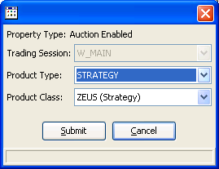

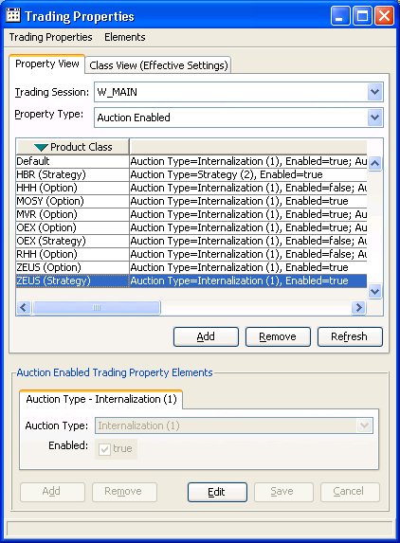

Trader GUI related changes
- The ‘Add New Internalization Order’ menu option to create an Internalized Complex order for AIM must be enabled.

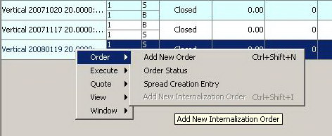

- When the user clicks the ‘Add New Internalization Order’ menu option the system must display the ‘Add New Internalization Order’ window to enter a paired complex order (i.e. Primary and Matched Order) as illustrated below.

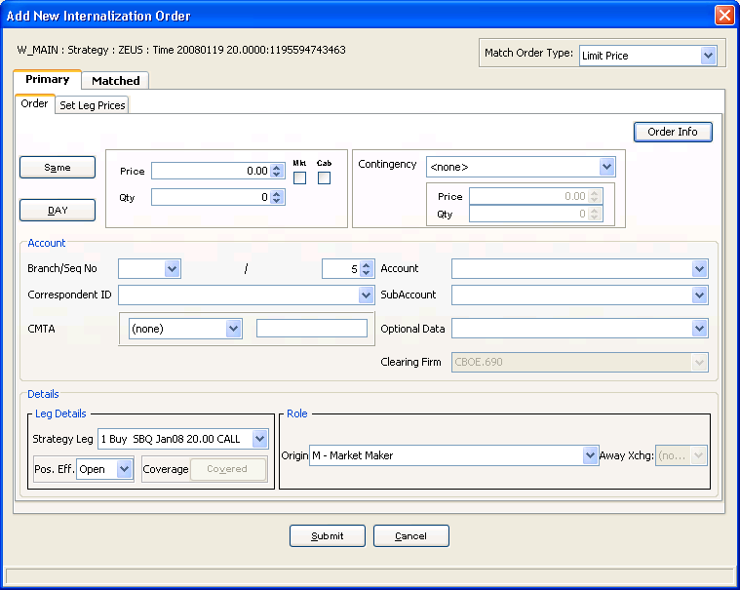

(Note: This screen shot is not accurate and is provided for illustrative purposes only)

Acronyms and Definitions
- PO ➔ Primary Order
- MO ➔ Matched Order
- CO ➔ Customer Order
- ASP ➔ Auction Starting Price
- EoA ➔ End of Auction Allocation specifications

- The BSM is considered as follows:
  - The Order side best market is the better price between the Top of the Spread Book (TSB) and the best price from Derived Spread Market (DSM) on the same side.
  - The Opposite side best market is the better price between the Top of the Spread Book (TSB) and the best price from Derived Spread Market (DSM) on the opposite side.)

